CRYSTAL LIU

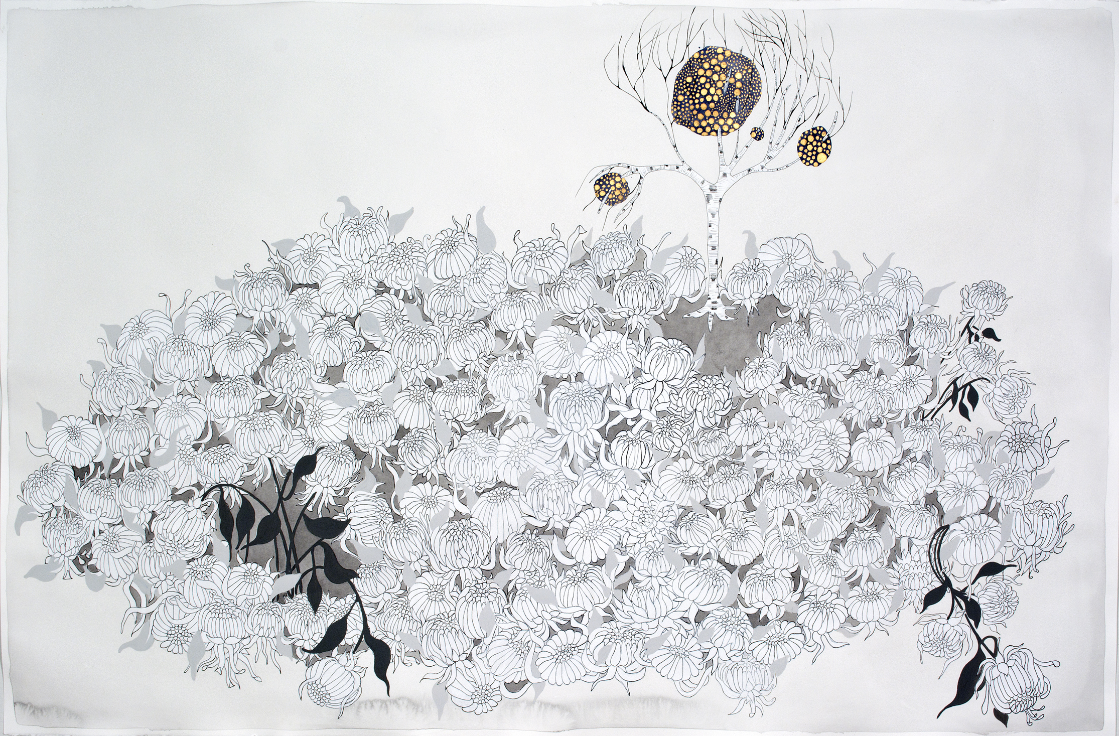

Crystal Liu is a Canadian born Chinese artist currently based in San Francisco, California. She received her A.O.C.A.D from the Ontario College of Art and Design in 2003, and her MFA from the San Francisco Art Institute in 2005.

Crystal Liu's photography and paintings on paper can be described as being psychological and emotional landscapes. Liu uses flora, fauna, geological phenomena, and meteorological events as metaphors for emotional states and personal relationships.

Her work has been exhibited in internationally in Asia and Canada, and nationally in San Francisco and New York. Her work is included in collections at the San Francisco Museum of Modern Art as well as the Progressive Art Collection, and has been featured in Artforum, Artnews, and the San Francisco Bay Guardian.

She is represented by Hosfelt Gallery in San Francisco and Galerie Du Monde in Hong Kong.

